Summary statistics | Correlation
   | N | Mean | St.Dev
  AGE | 758 | 21.8 | 3
  S | 758 | 13.4 | 2.2
  LW | 758 | 5.7 | .4
  KWW | 758 | 36.6 | 7.3
  IQ | 758 | 103.9 | 13.6
  EXPR | 758 | 1.7 | 2.1
  MRT | 758 | .5 | .5
  MED | 758 | 10.9 | 2.7
  SMSA | 758 | .7 | .5
  RNS | 758 | .3 | .4
  Variables | (1) |  | (2)
  (1) S |  | 1.000
  (2) IQ | 0.513 |  | 1.000
4.1 The summary statistics and correlation are as follow:
4.2 The three regressions can be show are follow:
 | - OLS | - OLS | - 2SLS
VARIABLES | LW | LW | LW
S | 0.030*** | 0.022*** | 0.069***
 | (0.008) | (0.008) | (0.013)
IQ |  | 0.003*** | 0.002
 |  | (0.001) | (0.004)
EXPR | 0.002 | 0.002 | 0.030***
 | (0.007) | (0.007) | (0.007)
TENURE | 0.020*** | 0.018** | 0.043***
 | (0.008) | (0.008) | (0.008)
RNS | -0.113*** | -0.106*** | -0.104***
 | (0.026) | (0.026) | (0.029)
SMSA | 0.124*** | 0.124*** | 0.135***
 | (0.025) | (0.025) | (0.027)
_IYEAR_67 | 0.001 | -0.002 | -0.053
 | (0.046) | (0.045) | (0.048)
_IYEAR_68 | 0.156*** | 0.155*** | 0.079*
 | (0.043) | (0.043) | (0.045)
_IYEAR_69 | 0.255*** | 0.248*** | 0.211***
 | (0.042) | (0.042) | (0.044)
_IYEAR_70 | 0.280*** | 0.264*** | 0.239***
 | (0.047) | (0.047) | (0.051)
_IYEAR_71 | 0.219*** | 0.204*** | 0.228***
 | (0.043) | (0.043) | (0.044)
_IYEAR_73 | 0.353*** | 0.340*** | 0.326***
 | (0.041) | (0.041) | (0.041)
MED | 0.005 | 0.004
 | (0.004) | (0.004)
KWW | 0.005** | 0.004*
 | (0.002) | (0.002)
AGE | 0.035*** | 0.037***
 | (0.006) | (0.006)
MRT | 0.113*** | 0.115***
 | (0.026) | (0.026)
Constant | 3.976*** | 3.781*** | 4.400***
 | (0.113) | (0.131) | (0.269)
Observations | 758 | 758 | 758
R-squared | 0.491 | 0.497 | 0.426

- From regression (1) to (2), adding IQ variable has reduced the coefficient on schooling from 0.03 to 0.022.
  - This is consistent with expectation based on omitted variable bias. Omitting IQ – the true ability estimator-will lead to overestimation of schooling. Including IQ will reduce this bias.
- From regression (2) to (3), treating IQ as endogenous and instrument for it has increased the coefficient for schooling from 0.022 to 0.069, and decreased the coefficient of IQ from 0.003(sig) to 0.002(insignificant).
  - This is inconsistent with expectation. From Hayashi page 242, since var(IQ) is greater than 0, we expect that instrument for IQ to reduce the measurement error will increase the coefficient on it (it was under-estimated with measurement error).
  - Intuitively this is easy to understand: if we assume that IQ is exogenous which in reality it is not, then it it is correlated with term in the epsilon term, and hence it is overestimated. Using 2SLS will reduce this bias.
  - This is may mean that IQ is not only measuring ability with error, it is endougenous and correlated with other unobservable factors that influence wage.

4.3 The J statistic and its p-value can be shown as follow:
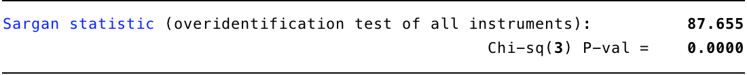

4.4 Below are the coefficients and standard errors of IV and 2SLS regressions
IV regression
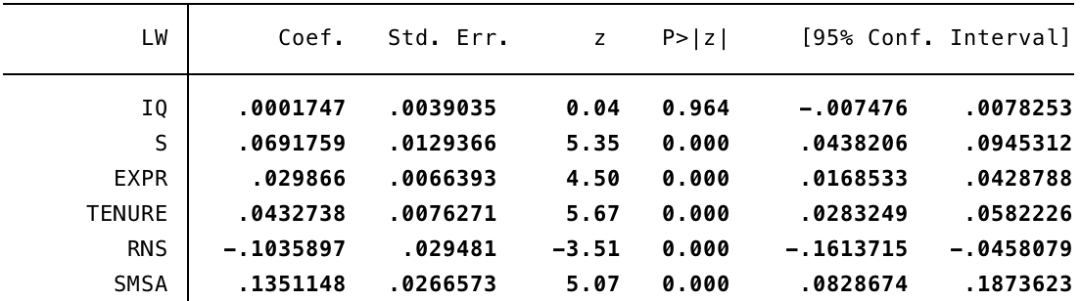
2SLS regression
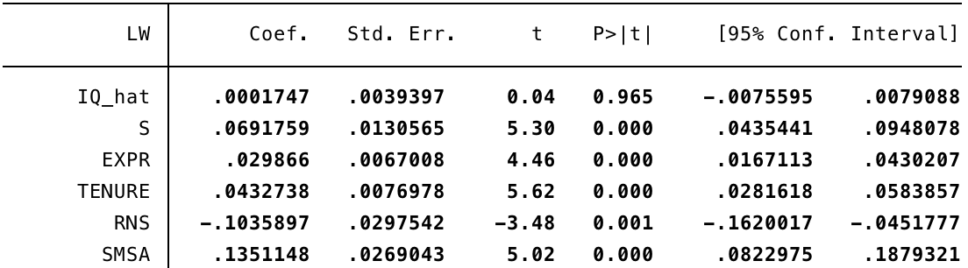

- It can be seen that the 2SLS regression has slightly higher standard error. This might because manually running the 2sls, LW regress on the fitted value of IQ without its errors included. (not sure about this)

4.5 The reason that schooling might be endogenous is that according to Griliches:
- Schooling cannot be itself treated as independent of the disturbance in the wage equation once an erroneous test measure is used instead of the true underlying ability dimension.
- Schooling decision is made in anticipation of economic returns, which is part of the disturbance term that is anticipated by the individual that will affect the outcome.
If we instrument for both IQ and S we will get regression coefficients:
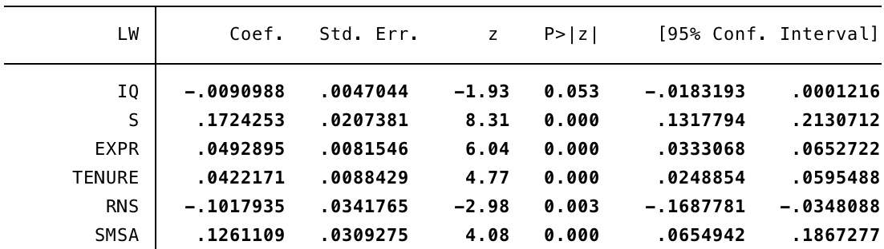

We can see that the coefficient on schooling increases significantly
- Reason: “the downward bias due to endogeneity and error of schooling is larger than the originally feared upward bias.” (Griliches)

4.6 See the graphs below. It can be shown that GMM estimation has smaller std. error. Also, the C statistic shows that schooling is not predetermined, with p = <0.01. Thus we conclude that schooling endogenous.
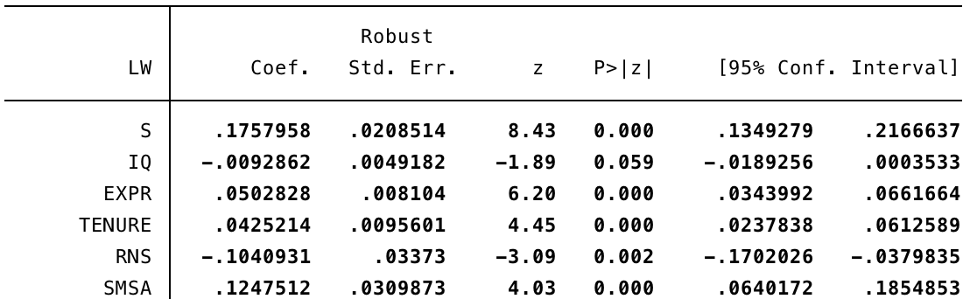

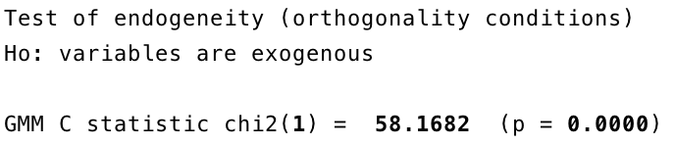

4.6 As can be shown from the result below, excluding these two variables makes the coefficients large and insignificant. Standard errors also explode. This is because that the first stage of instrumental variable approach assumes that the instrumented variable should have high correlation with instruments. As can be seen from the under-identification test, the model is under identified under this model. This explains the problem.
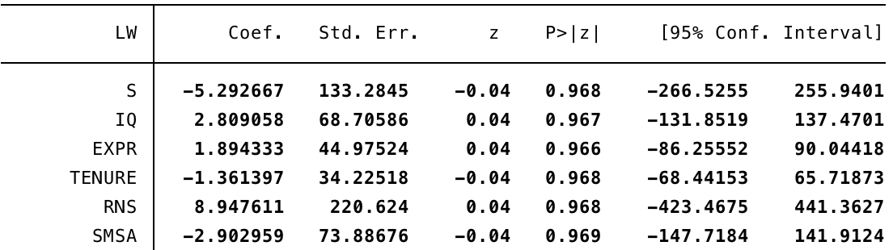
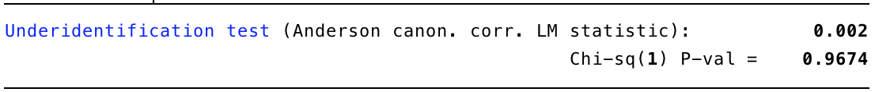

Code
********************************************************************************
* Q1 Summary Statistics
*****
ssc install asdoc
set more off
asdoc sum AGE S S80 LW LW80 KWW IQ EXPR EXPR80 MRT MRT80 MED SMSA SMSA80 RNS RNS80, stat(N mean sd) dec(1) save(sum_stat) replace
asdoc sum AGE S S80 LW LW80 KWW IQ EXPR EXPR80 MRT MRT80 MED SMSA SMSA80 RNS RNS80 if YEAR > 69, stat(N mean sd) title(After 69) save(sum_stat_69) replace
asdoc cor S IQ, title(Correlation) save(sum_stat_corr) replace

********************************************************************************
* Q2-3
*****
ssc install ivreg2

/*** Replicate Table 3.2 Hayashi ***/

* line 1 - without IQ
set more off
xi: reg LW S EXPR TENURE RNS SMSA i.YEAR MED KWW AGE MRT
outreg2 using rep_table_3.xls, replace dec(3) pdec(3)

* line 2 - with IQ
xi: reg LW S IQ EXPR TENURE RNS SMSA i.YEAR MED KWW AGE MRT
outreg2 using rep_table_3.xls, append dec(3) pdec(3)

* line 3 - instrumental variable apporach
set more off
ivreg2 LW S EXPR TENURE RNS SMSA i.YEAR (IQ=MED KWW AGE MRT S EXPR TENURE RNS SMSA i.YEAR), first
outreg2 using rep_table_3.xls, append dec(3) pdec(3)

********************************************************************************
* Q4 2SLS
*****
reg IQ MED KWW AGE MRT S EXPR TENURE RNS SMSA i.YEAR
predict IQ_hat
xi: reg LW IQ_hat S EXPR TENURE RNS SMSA i.YEAR

********************************************************************************
* Q5 2SLS with both IQ and S as endogeneous
*****
set more off
ivreg2 LW EXPR TENURE RNS SMSA i.YEAR (IQ S =MED KWW AGE MRT S EXPR TENURE RNS SMSA i.YEAR)
outreg2 using rep_table_4.xls, append dec(3) pdec(3)

********************************************************************************
* Q6 GMM estimation
*****
set more off
ivregress gmm LW EXPR TENURE RNS SMSA i.YEAR (S IQ=MED KWW MRT AGE)
estat endogenous S

********************************************************************************
* Q7
*****
ivreg2 LW EXPR TENURE RNS SMSA i.YEAR ( S IQ= MRT AGE)

